**FULL SUBTRACTOR**  
  
**EXP.NO: 24**  
  
**AIM:**  
  
To design and implement the full subtractor using  
Logisim simulator.  
  
**PROCEDURE:**  
  
1)      Pick and place the necessary gates.  
  
2)      Insert 3 inputs into the canvas.  
  
3)      Connect the inputs to the XOR gate, AND  
gate and OR gate.  
  
4)      Insert 2 outputs into the canvas.  
  
5)      Make the connections using the connecting  
wires.  
  
6)      Verify the truth table.  
  
**TRUTH TABLE:**  
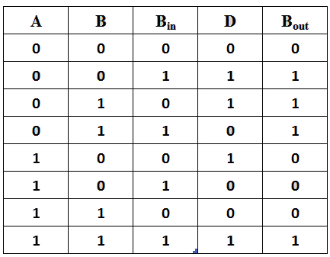  
  
 **D = A ⊕ B ⊕ Bin  
 Bout = A' Bin + A' B + B Bin**

**OUTPUT**  
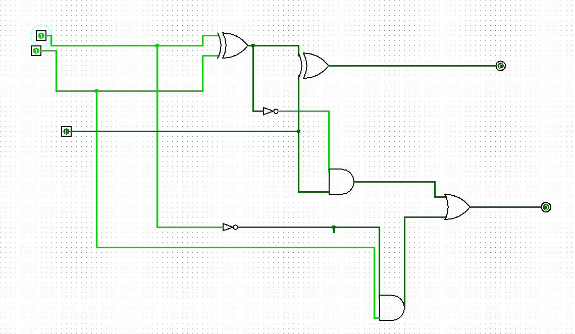  
  
   
  
  
  
  
  
  
  
  
  
**RESULT:**Thus full subtractor has been designed and implemented successfully using logisim  
simulator.